Spanish Study [8:11 AM, 5/15/2020] Done by Dr Pablo Campre at the University of Almeria
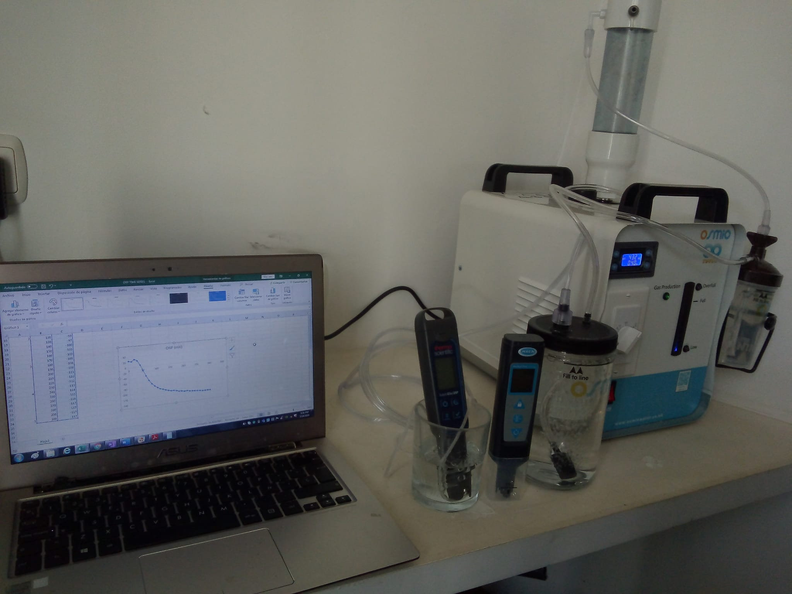
comparing Brown’s Gas and Pure hydrogen (H2) machines.

This is a comparison between HydrOxy (aka: Brown’s Gas, HHO) vs OxyHydrogen both at a
67% H2 : 33% O2 mixture.
The Osmio Infinity (private labeled AquaCure AC50) is only 555 mL/m of hydrogen (H2) at 100% gas production, which is far less than the Chinese Asclepius machine at 2000 mL/m of H2.
This is appropriate empirical evidence of the value of Electrically expanded Water (ExW)… an example proving Quality is better than Quantity.

Chart 1
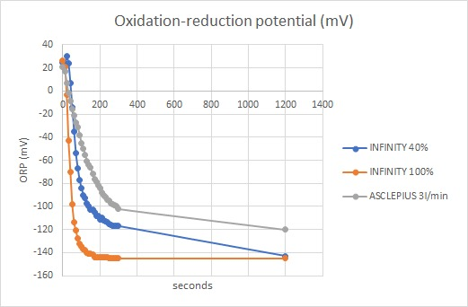
Infinity = HydrOxy Asclepius = OxyHydrogen

Chart 2
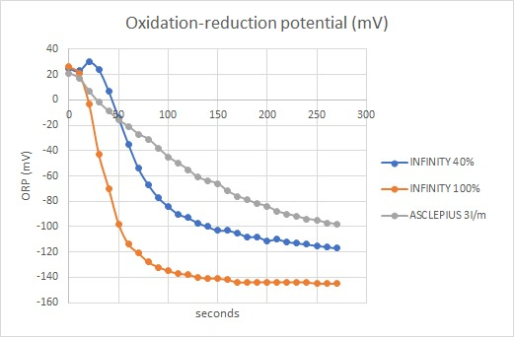
Infinity = HydrOxy (aka Brown’s Gas, BG or HHO) Asclepius = OxyHydrogen

Reference to define ORP and how it is affected by both H2 and pH.
ORP-Nernst-Analysis-rev4.4.2.pdf by Randy Sharpe
https://nebula.wsimg.com/e00f13c6a421e24d28be6558ff968736?AccessKeyId=781CCB9A394A3C0D544A&disposition=0&alloworigin=1

First...
HydrOxy (Brown's Gas, HHO, etc.) is defined as having ExW as one of it's 6 component gasses.

Just mixing H2 and O2 in a 67% : 33% ratio does NOT make the mixture HydrOxy.
That makes the mixture something generally called OxyHydrogen.

This is very confusing to people who do not understand the difference between Brown's Gas and OxyHydrogen. Like the ‘editors’ of WikiPeadia https://en.wikipedia.org/wiki/Oxyhydrogen

Brown's Gas contains 67:33 ratio of hydrogen and oxygen atoms, but the atoms are not all arranged as molecular H2 and O2. BG’s constituents are H, O, H2, O2, ExW and H2O.

See What is Brown’s Gas? https://eagle-research.com/q-what-is-browns-gas-bg/

Second...
For apples to apples (if it makes any difference) I'm assuming that both machines were combining their hydrogen and oxygen streams (the Infinity does it inherently and internally but the Asclepius (with PEM/SPE technology) would need to do it externally). At 100% gas production (total gas production = 833 mL/m), the hydrogen content of BG is 555 mL/m.

There is confusion out there because 67% (66.66666) hydrogen and 33% Oxygen (33.33333) mixtures are being assumed to be Brown's Gas when they are NOT.

Frankly it's difficult to KNOW from much of the scientific ‘hydrogen studies’ literature which is which… because they seldom define the working characteristics of the machines they are using to generate the hydrogen.

So pure H2 is easy. It is NOT BG.

But when they generate the gasses separately and then combine them, it's NOT BG, but it's difficult to tell from the studies common description of 67% hydrogen to 33% oxygen.

BG electrolyzers DO NOT separate the gasses as they are being generated... So ALL the gasses come out ONE hose.

BG is 67% hydrogen and 33% oxygen as well, but the way the atoms and molecules are arranged is significantly different AND BG has extra bio-available electrons (energy) that OxyHydrogen (2H2:O2) does not.

So the $30,000 machine is not actually making BG... And that is demonstrated with the ORP test. The extra electrons in the (much less volume of) BG lower the ORP more quickly than pure H2 can.

Third...
We describe ORP as a difference in potential between two points, the measured point (water sample), and a reference point (reference electrode of the ORP meter). This potential, expressed in millivolts, is called “redox potential” (Oxygen Reduction Potential or ORP),

There are many ways to change ORP, some of them very toxic or unhealthful.

BG (HydrOxy) changes the ORP (making it more negative) by adding electrons to the water.
The most healthful possible way to increase ORP (make it more negative).

This is important because you can actually drink water that ROBS energy from your body… If you drink water that has a positive ORP, it will GRAB electrons (energy) from your body to neutralize itself (go to zero). When you drink negative ORP water, it GIVES your body energy (electrons).

One way the ORP changes is when electrons are added to the water they neutralize the existing H+, allowing two H+ ions to become an H2 molecule, which is pH neutral. When H+ ions disappear, the ORP of the solution goes more negative, even though the pH of the solution doesn’t change (or changes very little).

So ORP is all about electrons, NOT dissolved hydrogen or pH.
As we add more electrons, the ORP goes more negative.

The above test is an excellent empirical confirmation that the ExW constituent of Brown's Gas is adding electrons to the water,.. something that hydrogen alone is much less effective at doing...

And SPECIFICALLY that the electrolyzers (hydrogen:oxygen generators) that use PEM/SPE technology do NOT make actual HydrOxy (Brown’s Gas, HHO) because they CANNOT make ExW.

At most they make OxyHydrogen (if the gas streams are combined).

Reactive oxygen species (ROS) are chemically reactive chemical species containing oxygen. ... 2 H+ + 2 e− + H2O2 → 2 H2O. In a biological context, ROS are formed as a natural byproduct of the normal metabolism of oxygen and have important roles in cell signaling and homeostasis.
The problem comes when the body doesn’t have the hydrogen and electrons to neutralize the ROS. Pure hydrogen gives the hydrogen needed… But NOT the electrons needed to stop the oxidative cascade. Brown’s Gas gives BOTH the hydrogen and electrons needed to ELIMINATE the ROS.

Further, BG is the absolute BEST antioxidant. Unlike ‘other’ antioxidants (like vitamin C), hydrogen is SELECTIVE, reduces ONLY the ‘bad’ ROS (leaves the good ones that we need) and BG contains ExW (with excess electrons) that the body can use DIRECTLY to stop oxidative cascade.

May the Blessings be
George Wiseman
http://eagle-research.life/about-me/

Is ORP Healthful?: (Next page)

There is a substantial miss-understanding that more negative ORP is more healthful... It is true AND not true!
It is VITAL to understand that WHY the ORP is negative is more important than the actual number.
Because there are several very UN-healthful ways to get negative ORP... Such as having minerals in the water that have a negative potential. ORP is measured as millivolts of potential (voltage).
So, for example, promoters of flow-through electrolyzers, (often called ionizers) that split the incoming water into 'Alkaline' and 'Acid' water can achieve extremely 'high' (negative) ORP depending on the water's impurities.
So for example: I have a K8 Kangan ionizer, made by Enagic.
If I take my 400+ ORP municipal tap water and run it first through my under counter RO machine, I get 200+ ORP (most minerals have been removed) and then I run that RO water through the K8, I achieve water (from the 'Alkaline' stream) that is about 0 ORP. I THEN bubble the 0 ORP water with BG and achieve -200 ORP.
Note that Enagic SPECIFICALLY does not recommend using RO water to feed their machines because the machines NEED the water impurities to work (as the electrolyte catalyst).
Brown's Gas makes water more negative ORP in the most healthful way possible; and achieves it with PURE water (usually distilled).
Brown's Gas (HydrOxy or HHO) adds electrons to the water, which reduces the H+ ions and allows them to form H2. The reduction of H+ causes the ORP reading to drop (go more negative). The BG also adds ExW gas to the water. ExW is a negatively charged (excess electrons) plasma form of water.
So the above Spanish experiment, comparing bubbling 3000 mL/m OxyHydrogen and 833 mL Brown's Gas into pure (distilled) water shows that the BG adds electrons that are NOT part of OxyHydrogen gas.

Efficiency and Brown’s Gas (next page)

Obviously there is no such thing as ‘actual’ over-unity. When there is an apparent over-unity then somebody has drawn the box too small, not measuring all relevant factors.

My favorite example is a light switch. A tiny push from my finger makes hundreds (even thousands) of watts ‘appear’. If one looks only at the light switch, it would appear ‘over-unity’. In reality, we just drew the ‘box’ too small, not considering all the factors.

In the case of Brown’s Gas, we see ‘extra’ gas production (volume) that Faraday Law does not predict. There’s TOO MUCH gas. Therefore something else is going on.

At first I theorized the ‘extra’ gas could be the result of the H and O atoms not recombining… That was proven wrong with spectrographic analysis…

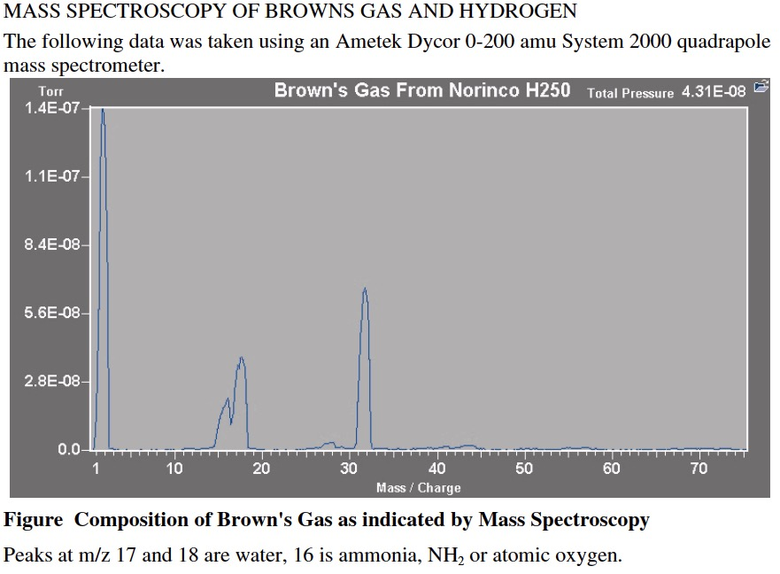

And the same analysis showed what is actually happening, but I didn’t ’see’ it (realize and understand) until I actually SAW the ‘extra' gas being produced in my transparent electrolyzers.

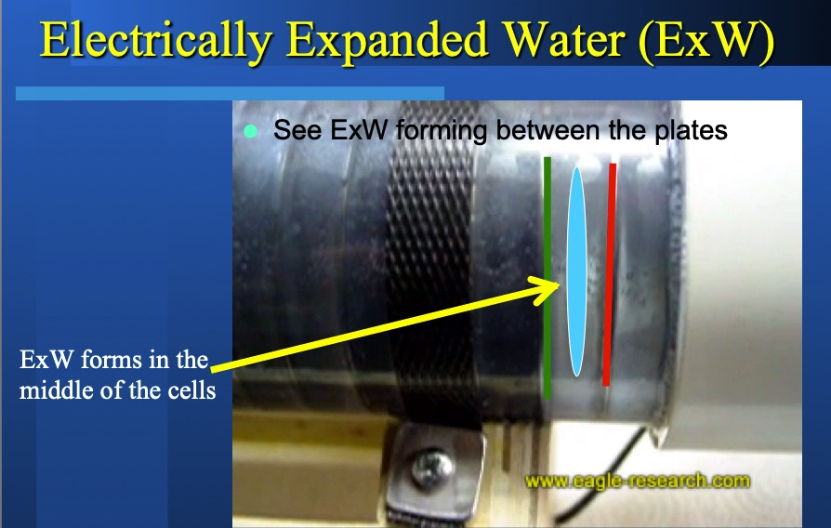

I have video online showing this phenomenon.
https://www.youtube.com/watch?v=amruwdyj3j0&t=20s

In a series cell electrolyzer each plate generates BOTH hydrogen and oxygen, depending on which side of the plate is ‘more positive or negative.

To keep things simple, just consider one cell (of the series of ce the green is the anode side of the plate (positive electrode) which is generating oxygen lls). The red is the cathode side of the plate (negative electrode) which is generating hydrogen. The blue circle is the area that is forming the ExW.

Bubbles are forming in the fluid between the plates. Bubbles that are not attached to the area od oxygen or hydrogen bubbles. A gas that is NOT oxygen or hydrogen.

You can see the same ‘line of bubbles’ being formed in the cell to the right of the example cell.

THEN I went back to the analysis and noted that when the Brown’s Gas was ‘dried’ (water vapor removed) there was STILL ‘water’ in the gas… A form of water gas that was not water vapor? How could that be?

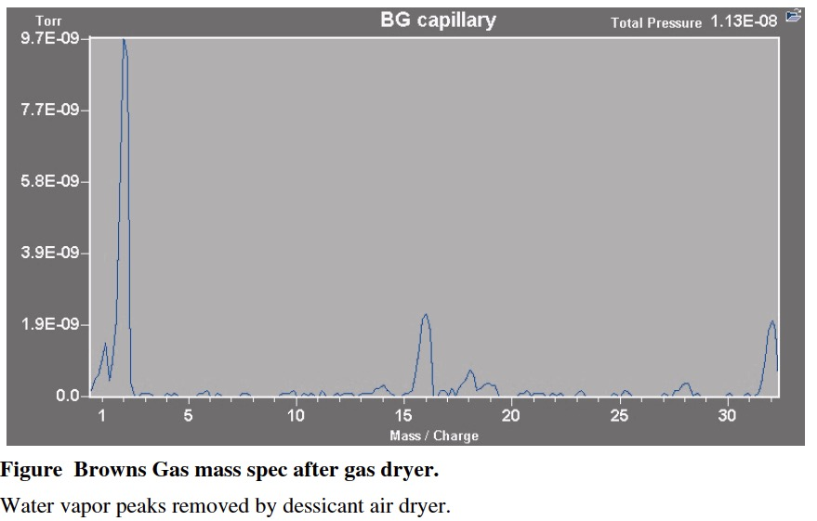

That’s when (in 1996) I developed the Electrically Expanded Water (ExW) theory.
ExW (as more research was done) turns out to be an electron rich 4th phase of water, a negatively charged plasma form of water.
Matter has 4 phases solid, liquid, gas and plasma.

The ExW forms in specially designed electrolyzers that do NOT have a membrane between the anode and cathode. The ExW is a gas formed as a ‘side effect’ of the electrolysis and is NOT part of the Faraday equations. The ExW is therefor an ‘extra’ gas that increases the volume of the gas mixture coming out of the electrolyzer, accounting for the ‘apparent’ over-unity.

Here’s an AquaCure model AC50 gas volume and efficiency testing video:
https://youtu.be/_BPbuCm1-II
To calculate the theoretical maximum production of 2H2:O2 per hour, use this formula:
((A / 26.8) * 16.8) * C = Liters of 2H2:O2
A = actual DC Amps flowing through your electrolyzer.
26.8 = amps per hour (one Faraday).
16.8 = molar volume (in liters) of diatomic hydrogen and oxygen gas in one hour produced per Faraday.
C = Number of cells in your series-cell electrolyzer (each cell has the same amperage flowing through it).
The AquaCure AC50 has 10 cells in series.
So for the AquaCure AC50 efficiency video, the theoretical maximum of ordinary di-atomic hydrogen and oxygen is:
((9.5/26.8)*16.8)*10 = 59.55 L/h.
The measured AquaCure AC50 production is 500 mL in 30.53 seconds (note that there is 3600 second in an hour).
So the actual gas volume produced is:
(3600/30.53) / 2 = 59 L/h
59 / 59.55 = about 99% efficient.
When have you ever heard of a traditional (or PEM/SPE) electrolyzer being near 100% efficient. This can ONLY happen because of the ‘extra’ gas production of the ExW.
And the AquaCure is using technology I abandoned in 1996. Anyone who has an AquaCure can measure its efficiency.
I AM going to make my own electrolyzers in the future versions of the AquaCure, but for now I’m just putting together the best I can find ‘off the shelf’ to keep the cost down and provide a needed product NOW. .
Experiments in my shop in 2009 were demonstrating 130% efficient in 2009, but then my life went sideways. I became a 24/7 caretaker of my sick wife and I nearly lost everything because I couldn’t work. I shut down my shop and put stuff in storage where it still is right now (March of 2020). My wife has since died and I’m now rebuilding my life. I hope to bring those experiments out of storage next year. Then I’d be able to show you (show everyone) efficiency test videos of MY Brown’s Gas technology.
In the meantime I have independent measurements from one of my customers who built an electrolyzer from the plans in my Brown’s Gas Book 2.
So let’s do an actual calculation to see how much Brown’s Gas Mario LeBell and his brother Ray were making in Vancouver, BC, Canada.
Using the volume measuring technique described above they measured one liter every 22 seconds coming out of their 60 series-cell electrolyzer using 3.5 amps DC at 128 volts DC.
Remember, voltage doesn’t matter to the actual electrolysis, only to the overall wattage efficiency of the machine (discussed later).
Mario measured 3.5 amps going into his 60 series-cell.

Theoretical maximum production of 2H2:O2 is: ((3.5 / 26.8) * 16.8) * 60 = 131.64 liters 2H2:O2.
So they are making (3600/22) 163.63 liters per hour of gas; which is greater than 131.64 liters, so they were making ‘super-efficient’ Brown’s Gas.
163.63/123.36 = 1.24% ‘quality’ gas. This means 24% more gas than 2H2:O2 could possibly have given.
So there is NO WAY that ’normal’ electrolyzers (like PEM/SPE) or ’traditional’ electrolyzers (with the membrane that separate the hydrogen and oxygen) can achieve even close to 100% efficiency let alone 130% efficiency… Because they do not (cannot) make ExW.

Another interesting ‘efficiency’ measurement is ‘Wattage Efficiency’ or watt-hours per SATP liter of gas produced. In this case we measure the overall efficiency of the whole electrolyzer itself (not being concerned with the number of cells). We just measure the watt-hours (DC amps and volts) it takes to make the gas and the gas volume in liters per hour.

For example in the above AquaCure Volume measurement video:
(Amperage x Voltage = Wattage) / Measured gas volume in liters per hour at ambient air temperature and pressure.
Gas volume = (0.5 (3600/30.53) = 58.958401572224042 = 59 lph

(9.5 A x 25.17 V) / 59 = 4.05 Wh/L
Which is excellent and currently ‘standard in the industry’ (traditional electrolyzers measured at greater than 17 Wh/L).

But this is the efficiency is far below ‘my’ standard. Here is an independent testing of one of my ER1200 WaterTorch (built in 2008), showing 2 Wh/L efficiency.
https://eagle-research.com/wp-content/uploads/2020/05/ER_water_Torch_test_3.pdf

The above test does not take into account heat production as another manifestation of energy (thus exhibiting further ‘over-unity’).
ER1200 WaterTorches normally operate at about 175°F and weigh about 165 lbs ‘wet’.

My experimental electrolyzers now measure under 1 watt-hour per SATP liter of gas produced.

May the blessings be
George

Health and ExW (next Page)

About 86% of a human is made of Hydrogen and Oxygen (62% + 24%).
HydrOxy is a special mixture of Hydrogen, Oxygen and ExW (ExW is a ‘plasma’ form of water that provides bio-available electrons). This trifecta of essential nutrients supports the regenerative processes that are vital to all ‘water based’ living systems (plants, fish, mammals… including humans).

Hydrogen is THE essential building block of life as we know it. Our bodies are mostly MADE of hydrogen.
Hydrogen is also involved directly or indirectly with every chemical process in the human body.

While hydrogen is the world’s most efficient and effective anti-oxidant (cleans up oxidative free radicals by turning them into water), it’s the ExW (extra electrons) that really gives Brown’s Gas it’s healthful boost. These electrons are bio-available and do several things at once:
- They provide ENERGY that the body NEEDS to heal. Hydrogen is a ‘building block’ but like any brick, it just lays there until ENERGY puts it in place. Hydroge alone is insufficient for health, it takes energy to make it effective. Bio-available electrons are an excellent energy source.
- When ill, the body has used up it’s energy reserves and often has compromised energy ‘generation’ capability. These bio-available electrons ‘bypass’ all that and give the body a ‘jump start’ toward healing and reactivating it’s own energy production capability.
- They DIRECTLY stop free radical damage by giving the electrons needed to STOP the oxidative cascade.

If ExW increases EZ gel, this could be another reason that Brown's Gas is so healthful.
https://gembared.com/blogs/musings/debunking-red-light-therapy-mechanisms-how-does-it-really-work

